[Print on Local Trust headed paper]

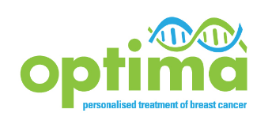
Documentation of Verbal Consent to Audio-recording
OPTIMA Qualitative Recruitment Study

Complete when the patient has not been sent the QRS PIS in advance of the first oncology appointment.

Study Title: | Optimal Personalised Treatment of early breast cancer using Multi-parameter Analysis: Qualitative Recruitment Study
Study Number: | ISRCTN42400492  IRAS ref. 95626
Patient Initials:
Patient Study Number*:

Investigator Statement and Signature
To be completed by the investigator or designee receiving verbal consent
I confirm that the patient has verbally consented to having their appointment audio-recorded for research and training purposes.
Investigator name (print):  ______________________________ | Signature:  _____________________________ | Date:  _______________

Please provide the patient with the OPTIMA Qualitative Recruitment Study Patient Information Sheet.
If the patient subsequently signs the “Audio-recording of consultations” Consent Form, contact the Warwick Clinical Trials Unit to register the patient’s participation.
*Insert patient study number when issued by WCTU
Should the patient decide not to sign the “Audio-recording of consultations” Consent Form then all recordings must be destroyed. No recordings may be transmitted to the University of Bristol unless the patient has completed the consent form.
The original Consent Form must be retained on site and should be stored in the trial site file with a copy filed in the patient’s hospital notes.

